**3GPP TSG-RAN WG4 Meeting #114-bis R4-2504382**

**Wuhan, China, April 7th – 11st 2025**

**Source:** Ericsson

**Title:** Simulation results for Rel-19 SCM for demodulation

**Agenda item:** 7.16.2

**Document for:** Information

# Introduction

In RAN4#114 meeting, companies agreed to run simulations for PMI with eType-II and the parameters were agreed in WF [1]. Furthermore, some simulations for SNR scaling factor and channel characters comparison between different methodologies are also provided in this contribution.

# Simulation

## 2.1 SU-MIMO PMI with eType-II codebook

Table 2.1 Parameters for eType-II

|  |  |  |  |  |  |  |
| --- | --- | --- | --- | --- | --- | --- |
| Parameter | | | Unit | 8TX | 16TX (for information) | 32TX (for information) |
| Bandwidth | | | MHz | 40 | | |
| Subcarrier spacing | | | kHz | 30 | | |
| Duplex Mode | | |  | TDD | | |
| TDD DL-UL configurations | | |  | FR1.30-1 as specified in Annex A | | |
| Antenna configuration | | |  | 8 x 4  (N1,N2) = (4,1) | 16 x 4  (N1,N2) = (4,2) | 32 x 4  (N1,N2) = (8,2) |
| NZP CSI-RS for CSI acquisition | CSI-RS resource Type | |  | Periodic | | |
| Number of CSI-RS ports (*X*) | |  | 8 | 16 | 32 |
| CDM Type | |  | CDM4 (FD2, TD2) | CDM4 (FD2, TD2) | CDM4 (FD2, TD2) |
| Density (ρ) | |  | 1 | 1 | 1 |
| First subcarrier index in the PRB used for CSI-RS (k0, k1, k2, k3) | |  | Row 8,(4,6) | Row 12,(2, 4, 6, 8) | Row 17,(2, 4, 6, 8) |
| First OFDM symbol in the PRB used for CSI-RS (l0) | |  | Row 8,(5) | Row 12,(5) | Row 17,(5, 12) |
| CSI-RS  interval and offset | | slot | 10, 0 | | |
|  | |  |  | | |
| cqi-FormatIndicator | | |  | Wideband | | |
| pmi-FormatIndicator | | |  | Not configured for eType II  FFS Subband or Wideband for Type I | | |
| Sub-band Size | | | RB | 8 | | |
| csi-ReportingBand | | |  | 11111111111111 | | |
| Codebook configuration | Codebook Type | |  | 1. typeII-r16 2. typeI-SP | | |
| eType II CB config | *paramCombination-r16* |  | 6  (L =4, *pν* =1/2, β=1/2 ) | | |
| R*(numberOfPMISubbandsPerCQISubband-r16)* |  | 1 | | |
| (CodebookConfig-N1,CodebookConfig-N2) | |  | (4,1) | (4,2) | (8,2) |
| (CodebookConfig-O1,CodebookConfig-O2) | |  | (4,1) | (4,4) | (4,4) |
| CodebookSubsetRestriction | |  | 0x FFFF | 0x 7FF FFFF FFFF FFFF FFFF | 0x  FFFF FFFF FFFF FFFF  FFFF FFFF FFFF FFFF  FFFF FFFF FFFF FFFF  FFFF FFFF FFFF FFFF |
| RI Restriction (typeII-RI-Restriction-r16) | |  | Rank 2: 0010  Rank 4: 1000 | | |
| Physical channel for CSI report | | |  | PUSCH | | |
| CQI/RI/PMI delay | | | ms | 7 | | |
| Maximum number of HARQ transmission | | |  | 4 | | |
| Measurement channel | | |  | R.PDSCH.2-8.3 TDD | | |
| PDSCH & PDSCH DMRS Precoding configuration for random Precoding | | |  | Single Panel Type I, Random precoder selection updated per slot, with equal probability of each applicable i1, i2 combination, and with i1 wideband granularity and i2 subband granularity | | |
| Note: Use DM-RS based FOE and compensation. | | | | | | |

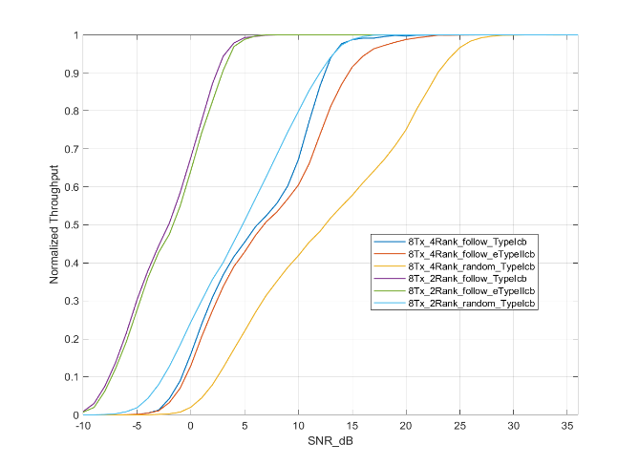 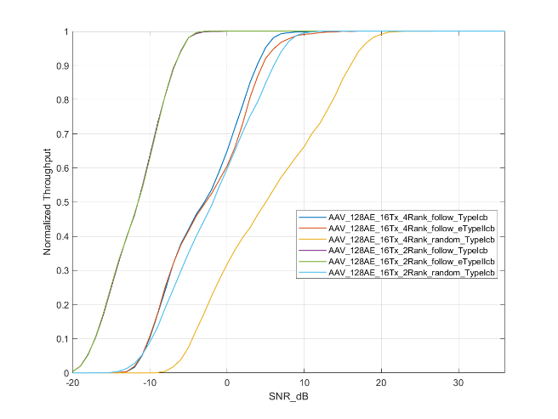

1. 8AE 8Tx (b) 128AE 16Tx

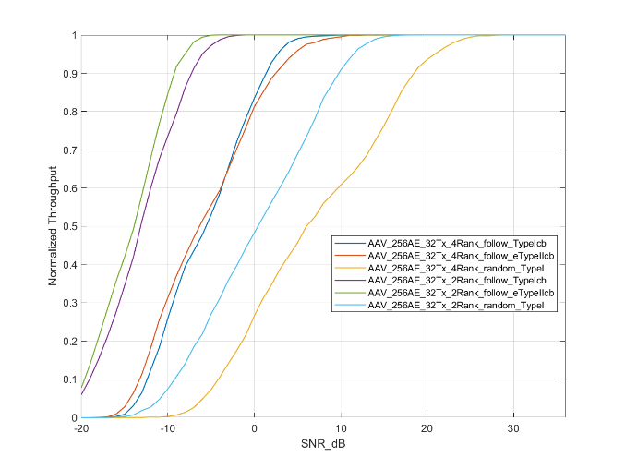

(c) 256AE 32Tx

**Figure 2.1-1 PMI simulation results for 4 ranks and 2 ranks with Type-I and eType-II**

Table 2.1-2 Results summary of Type-I and eType-II codebook

|  |  |  |  |  |  |  |
| --- | --- | --- | --- | --- | --- | --- |
| BS antenna Config. | Rank | Channel model | Codebook | SNR of Follow PMI at 90% NThp | NThp. of Random PMI | Gamma |
| **256AE 32Tx**  **SV (16,8,2, 8, 1)** | 4 | FR1 Uma CDL | Type-I | 1.37 | 32% | 2.81 |
| eType-II | 2.48 | 37% | 2.43 |
| 2 | Type-I | -7.26 | 17% | 5.29 |
| eType-II | -9.26 | 10% | 9 |
| **128AE 16Tx**  **SV (16,4,2, 8, 1)** | 4 | FR1 Uma CDL | Type-I | 3.88 | 46% | 1.95 |
| eType-II | 4.59 | 49% | 1.83 |
| 2 | Type-I | -6.78 | 26% | 3.46 |
| eType-II | -6.82 | 25% | 3.6 |
| **8AE 8Tx**  **(1, 4, 2, 1, 1)** | 4 | FR1 Uma CDL | Type-I | 12.47 | 50% | 1.8 |
| eType-II | 14.67 | 57% | 1.57 |
| 2 | Type-I | 2.4 | 37% | 2.43 |
| eType-II | 2.92 | 40% | 2.25 |

1. With 256AE and 32Tx, eType-II codebook starts outperforming Type-I codebook for rank 2 and partially over low SNR values up to -4dB for rank 4. For other antenna configuration and rank combinations, no gain of eType-II is observed. Therefore, to reap the benefits of beam resolution in eType-II codebook, high number of transmit antenna elements and CSIRS ports might be necessary.

Table 2.1-3 SNR at 70% normalized throughput for SU-PMI comparison

|  |  |  |  |  |  |  |
| --- | --- | --- | --- | --- | --- | --- |
| BS antenna Config.  (M,N,P,Ms,Ns) | Port mapping | Channel model | Rank | SNR (dB) | | |
| Type-I follow PMI | eType-II follow PMI | Type-I Random PMI |
| 256AE (16,8,2,8,1) | SV | FR1 Uma CDLC | 4 | -11 | -13 | 4 |
| 2 | -3 | -3 | 13 |
| 128AE (16, 4, 2, 8,1) | SV | FR1 Uma CDLC | 4 | -10 | -10 | 2 |
| 2 | 1 | 0 | 11 |
| 8AE (1, 4, 2,1,1) | 1 to 1 | FR1 Uma CDLC | 4 | 2 | 2 | 8 |
| 2 | 13 | 10 | 18 |

## 2.2 Eigen value of CDL channel

In this section, the eigen value of FR1 Uma CDLC (channel A1) is analyzed during the simulation of SU-PMI above. The different eigen value CDF distribution with antenna configurations are captured in below figures.

1. The CDF curves become steeper with the increasement of antenna elements.
2. The eigen modes get less variant with the increasement of antenna elements.

# Conclusions

In the previous sections we made the following observations:

Observation 1 With 256AE and 32Tx, eType-II codebook starts outperforming Type-I codebook for rank 2 and partially over low SNR values up to -4dB for rank 4. For other antenna configuration and rank combinations, no gain of eType-II is observed. Therefore, to reap the benefits of beam resolution in eType-II codebook, high number of transmit antenna elements and CSIRS ports might be necessary.

Observation 2 The CDF curves become steeper with the increasement of antenna elements.

Observation 3 The eigen modes get less variant with the increasement of antenna elements.

Based on the discussion in the previous sections we propose the following:

* **No table of figures entries found.**

# References

[1] R4-2502378, Way Forward for [114][322] FS_NR_demod_SCM, Nokia

[2]